**SENTIMENT ANALYSIS**







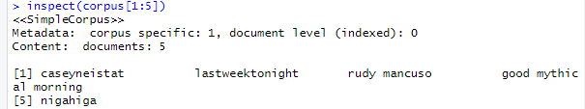**\**

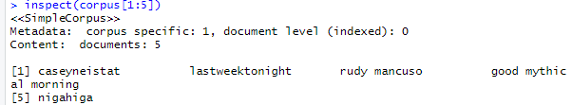





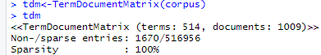

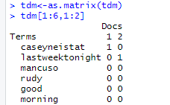





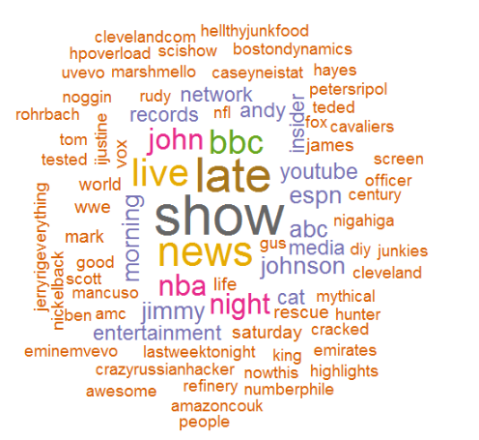



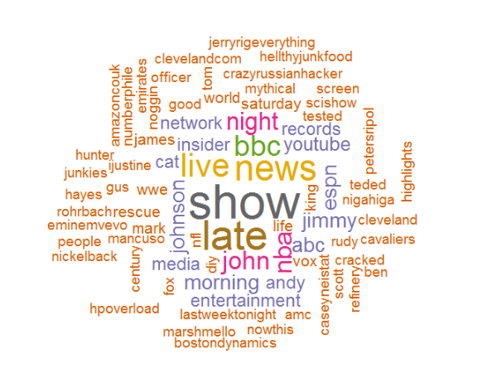



























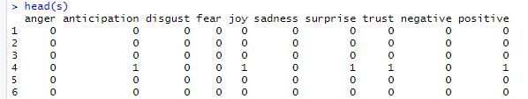





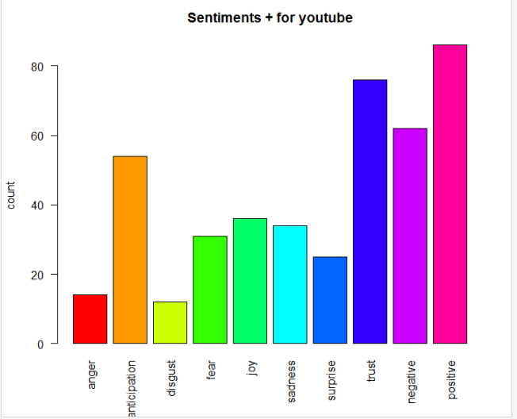

**Conclusion:**

By observing the sentiments graph we conclude that the sentiments regarding YouTube is positive, since the frequency count for positive sentiment is more as compared to the other emotions or sentiments.